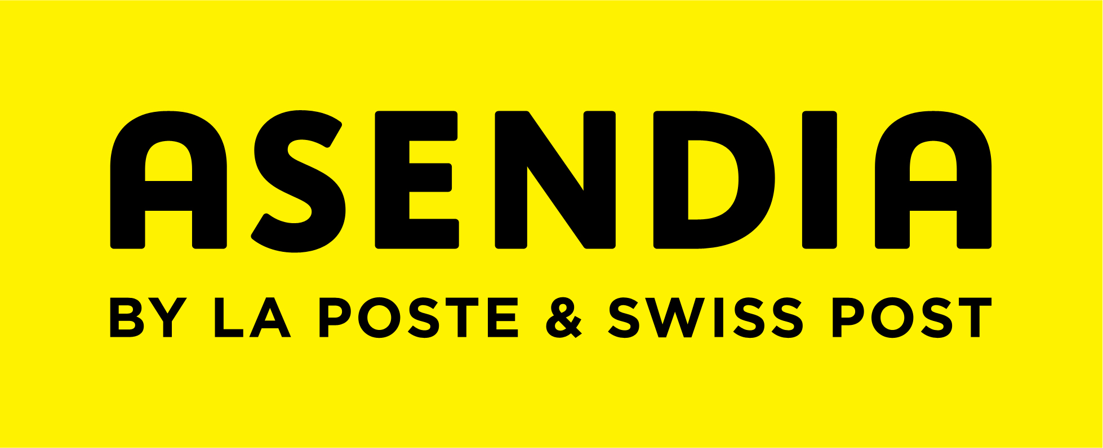

Asendia UK Anti Modern Slavery and Human Trafficking Statement 2017
Asendia UK is committed to ensuring that there is no modern slavery or human trafficking in any part of our business. We are committed to acting ethically and with integrity in all our business relationships and implementing effective systems and controls to ensure, insofar as we are able, slavery and human trafficking is not taking place anywhere in our supply chains.
Asendia UK acknowledges its responsibilities under the Modern Slavery Act 2015 and will strive to ensure transparency within the organisation and with suppliers of goods and service to our organisation.
Asendia UK is a subsidiary of Asendia, formed from a joint venture between La Poste and Swiss Post. As a global provider of international mail, business mail and shipping services, we offer a complete solution for the business, retail, direct marketing and publishing sectors. Asendia employs more than 1,000 people worldwide, has offices in 15 countries and a global network of delivery partners and Asendia UK is one of the largest operations with 4 facilities in the UK.
As part of our due diligence processes we identify and mitigate risk, by;
- Managing all our offices with the aim of ensuring optimum control of the work environment;
- Building long standing relationships with suppliers and customers and making clear our expectations of business behaviour;
- With regard to national or international supply chains, expecting those entities to have suitable anti-slavery and human trafficking policies and processes, including each of the entities to adopt a policy of due diligence on the next link in the chain; and
- Encouraging an environment of reporting concerns and the protection of whistleblowers.
Asendia UK does not and will not knowingly support or deal with any business involved in slavery and human trafficking.
Future steps for 2017 – 18
Asendia UK understands that it has an ongoing responsibility to continue to assess and mitigate the risk of modern slavery for the long term and has started to understand the nature of that risk. Asendia UK recognise that the nature of the risk may change over time and ongoing vigilance will be required.
Going forwards into our next financial year 2017 – 18, we hope to continue to combat modern slavery in the following ways:
- Our UK Board of Directors takes responsibility for implementing this policy statement and its objectives and shall provide resources (training etc) to ensure that slavery and human trafficking is not taking place within the organisation and, to the best of our abilities, within our supply chains.
- Measure and benchmark our performance against the action steps identified in this statement, best practice amongst similar commercial organisations, and emerging caselaw and identify further areas of improvement to add to our annual compliance risk management process.

To date we have not been made aware of, or discovered any incidences of human trafficking or slavery within our own business or our direct supply chain. However, as a business, we are committed to continually strive to ensure that any mistreatment of individuals is identified and eradicated at each touchpoint of our business and direct supply chain.
This statement is made pursuant to section 54(1) of the Modern Slavery Act 2015 and constitutes our slavery and human trafficking statement for the financial year ending 31 May 2017 and will be reviewed annually.
On behalf of the board of Asendia UK Limited

